Activity 1: Test Scenario 1

Description:

In this activity, I created a test scenario in the ServiceNow application to understand and verify the given process. I followed the required steps and entered the necessary details. After completing the process, I checked the system response and verified the result. The test scenario was completed successfully.

Process

First, I opened the ServiceNow application and logged in. Then I navigated to the required module and opened the required record. I entered the required information and performed the given actions step by step. Finally, I verified the result and confirmed that the process was working as expected.

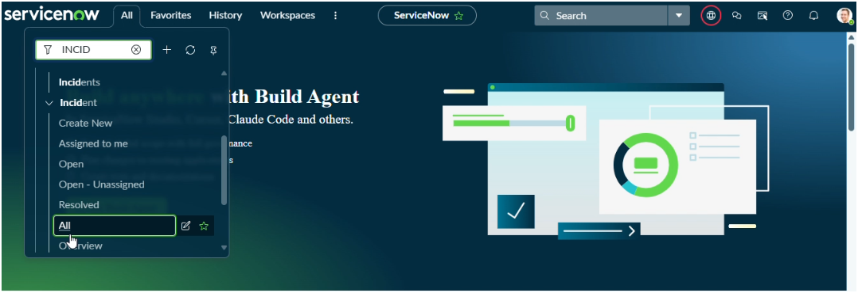

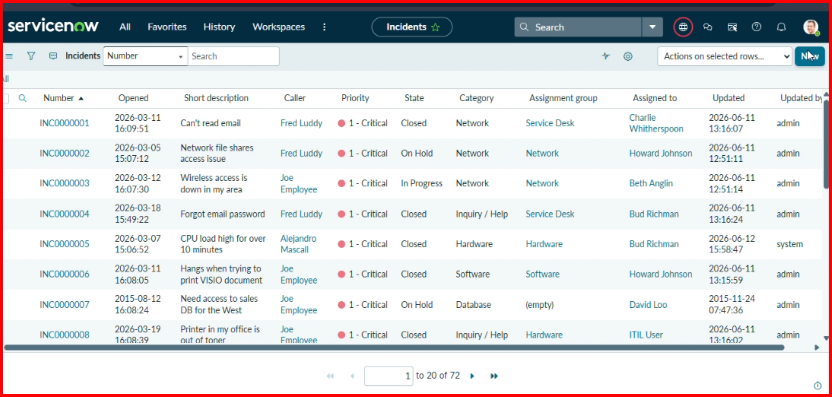

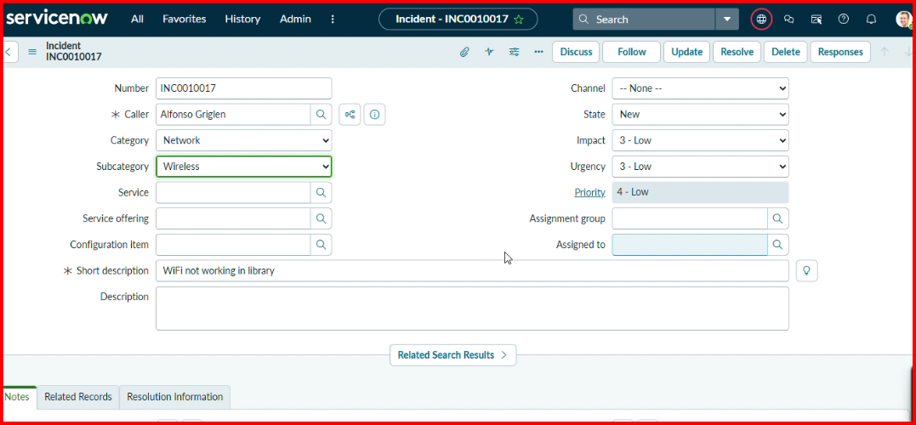

Result
The process was completed successfully, and the expected result was obtained.

